1. Open the MMF creator
2. Press **Alt + F11** on your keyboard to bring up the code editor window.
3. Go to **Tools ⇨ References**

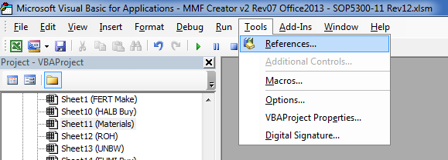

1. Scroll down until you find **“Microsoft Outlook 14.0 Object Library”** and make sure that the box is checked
   1. If you see a **“Microsoft Outlook 15.0 Object Library”** make sure it is NOT checked
2. Click the **OK** button
3. Close the code editor window
4. Save the MMF Creator file
5. It should now be ready to use